Finalprojectreport
– Introduction
• What is the problem
• What is your approach to solve it
– Approach and Method
• Details about the approach(s) you implemented and test • How does it works and why
• What are the limitations
– Results
• Describes the experiments that you have done
– Various parameters, different implementation choices
• Which metrics did you use to measure success and why • Use plots
• What are the final results

Introduction To Image Stitching
The problem:
From series of photos that were made from static rotating camera, create one image that will represent the space, where the original made images transformed to the other image’s plane. To achieve that task a couple of setting should be done.

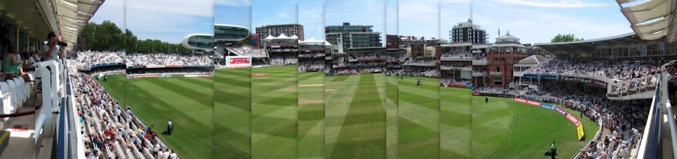

The result of right stitching:

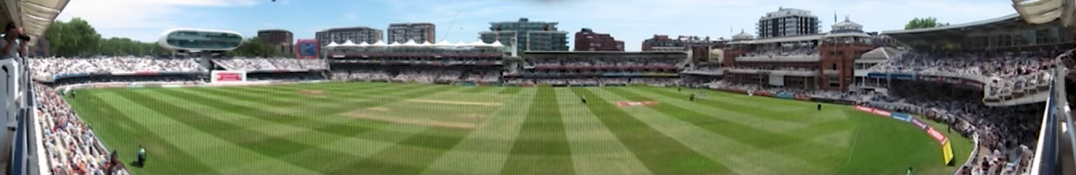

Another example:

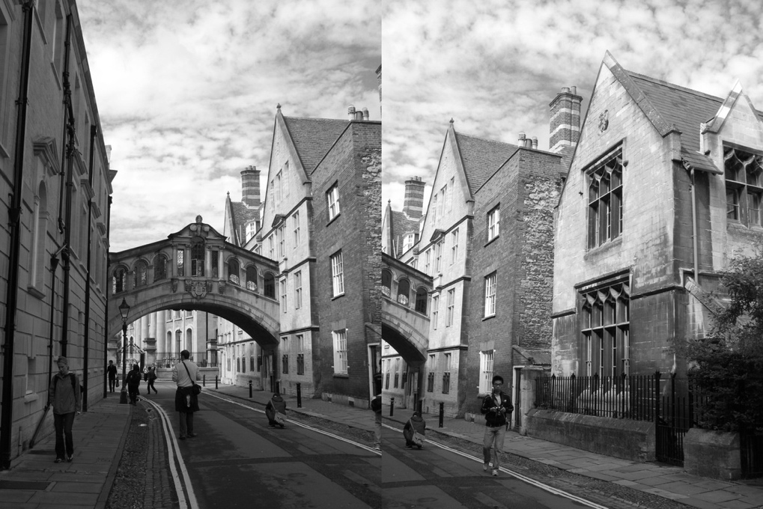

Result
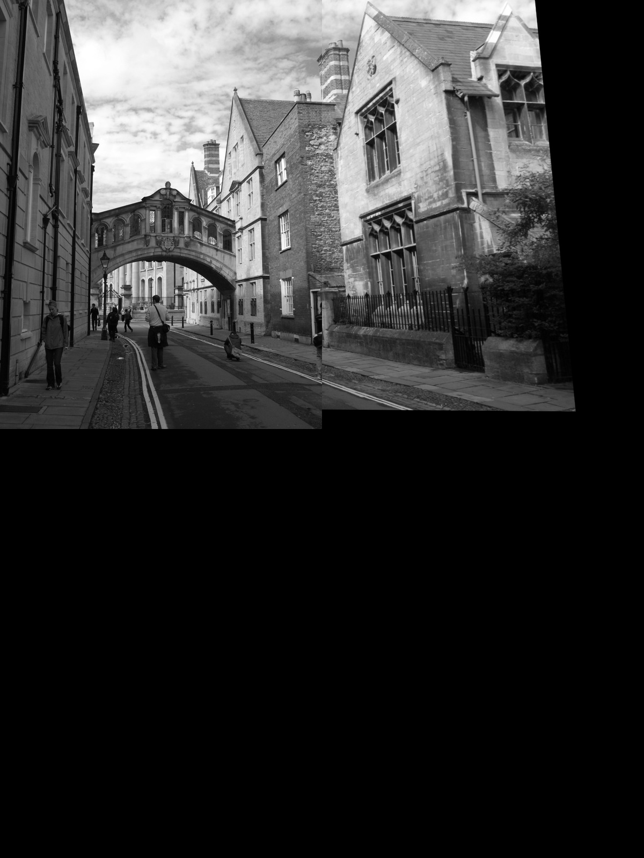

In the second example you can notice how the right image slightly leaning left. This is the fine [… correlation? Translation? ] of the second image to the first one.

The problem is to find the homography matrix that will move each pixel to the right place s.t the set of images will looks like one complete image without distortions.

By following the instructions we achieved the result of example No2.

Image Stitching Steps:
- Detect keypoints in 2 given images
- Match the most common points of the two images using RANSAC
- Find the Homography matrix
- Transform one image to the other’s image plane
- Wrap the two images

Using OpenCV we detect the features of the images by using the SIFT algorithm (Scale Invariant Feature Transform). As we seen in the lectures there is another approaches to detect features in image. One of them is Harris corner detection. Harris corner detection is bad for us because it is not scale invariant.
The following 3 images explaining the reason of Harris corner failure.

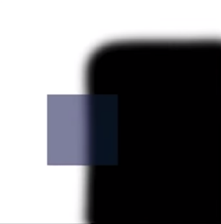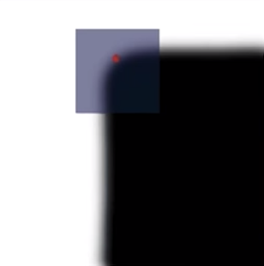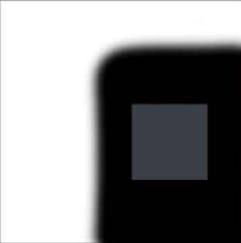
If the corner is scaled up and the filter window (light blue color) is on the corner’s side or on the x,y edge then we can still recognize that that is a corner, but if the filter window falls on the corner, then we lose the indication of the corner.

RANSAC
Random Sample Consensus, is allowing us effectively remove outliers and determine the strongest linear model of the dataset.
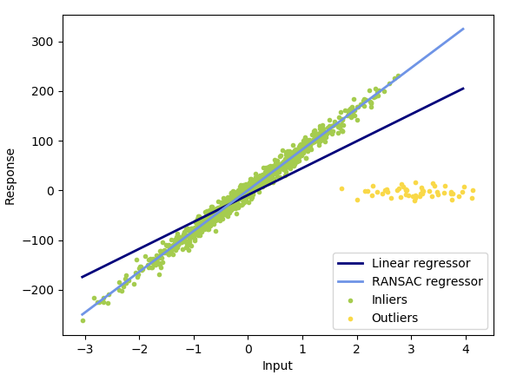
As we can see in the example above, there is two lines (models). One for the Linear regression and one for the RANSAC. Because of the outliers (yellow dot group) the Linear model has wrong estimation, on the other hand RANSAC model show’s the most estimated model by ignoring the false data (outliers). The model runs on iteration over the dataset, on each iteration it selects randomly 4 dots, and calculate the distances from them to the line. After that the model checks how mush data is placed near (by some delta) or on that line. The model with maximum number of dataset that placed on the same line returned.
After running RANSAC we render two images that show’s the inliers and the outliers of the images.

Homography
After using the RANSAC, we determine the inliers that best fit to the model. Now we want to fine the matrix that will transform one plane pixel to another plane, we want transform image2 to the plane of image1.
When an image is transformed to another image’s plane, it ensures that the epilines in both images are parallel to this image plane. This is a useful property that can be harnessed to reduce the number of searches while matching keypoints in 2 images, since a given point in an image will lie on the corresponding epiline in the other image (observed from a different point in space).

Homography can be mathematically expressed as
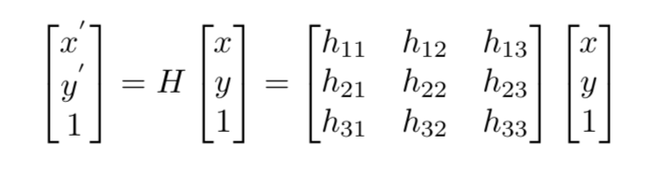

Our Tests and Results
